Here’s a structured, slide-ready set of Amazon S3 best practices in bullet points for quick recall:
🔍 Audit Configurations
- Use AWS Config to define rules and detect misconfigurations.
- Leverage AWS Trusted Advisor for compliance with AWS best practices.
- Regularly review bucket permissions, encryption, versioning, and logging.
📊 Logging & Monitoring
- Amazon CloudWatch: Track usage, error rates, and set alarms.
- AWS CloudTrail: Capture API calls for auditing and anomaly detection.
- Presigned URLs: Provide temporary, controlled access to objects.
- AWS CloudFront: Distribute content securely via CDN, reducing bucket exposure.
- Cross-account access: Grant permissions securely between AWS accounts.
- CORS: Enable cross-origin access when required for multi-domain apps.
🔐 Access Controls
- Apply IAM policies for fine-grained access.
- Use bucket policies for additional restrictions.
- Enable MFA for sensitive operations.
- Block public access with S3 Block Public Access settings.
🔒 Encrypt Data
- Enable server-side encryption or use customer-provided keys for data at rest.
- Use SSL/TLS for secure data in transit.
- Enforce encryption policies to prevent misconfigured uploads.
🗂️ Versioning
- Enable S3 Versioning to protect against accidental deletions or overwrites.
- Recover from unintended user actions or application failures.
📤 Secure Sharing
- Share objects via presigned URLs or CloudFront distributions.
- Avoid public bucket access; prefer controlled IAM-based sharing.
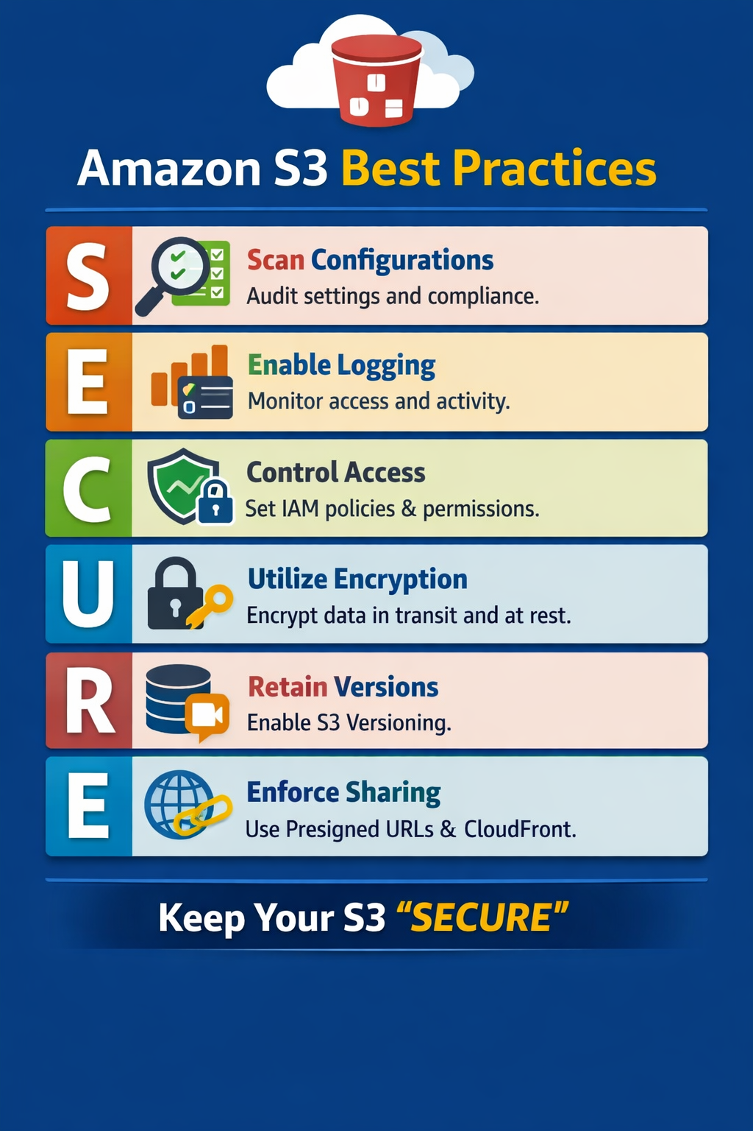
Here’s a concise, slide-ready summary of Amazon RDS best practices in bullet points:

🔐 Security
- Apply IAM policies and security groups to control access.
- Use encryption at rest and in transit.
- Enable automatic backups and Multi-AZ deployments for resilience.
📈 Monitoring & Metrics
- Use Amazon CloudWatch to track CPU, memory, IOPS, and connections.
- Set alarms for threshold breaches and resource exhaustion.
- Review Enhanced Monitoring and Performance Insights for deeper analysis.
⚙️ Query Tuning
- Optimize frequently used and resource-heavy queries.
- Use EXPLAIN plans and indexes to improve performance.
- Reduce cost by minimizing inefficient query patterns.
🔄 Scaling & Failover
- Use read replicas for horizontal scaling.
- Test failover scenarios to ensure high availability.
- Choose appropriate instance classes based on workload.
🧠 Engine-Specific Practices
- Follow tailored best practices for MySQL, PostgreSQL, Oracle, SQL Server, MariaDB.
- Understand engine-specific features like parameter groups, storage options, and replication modes.
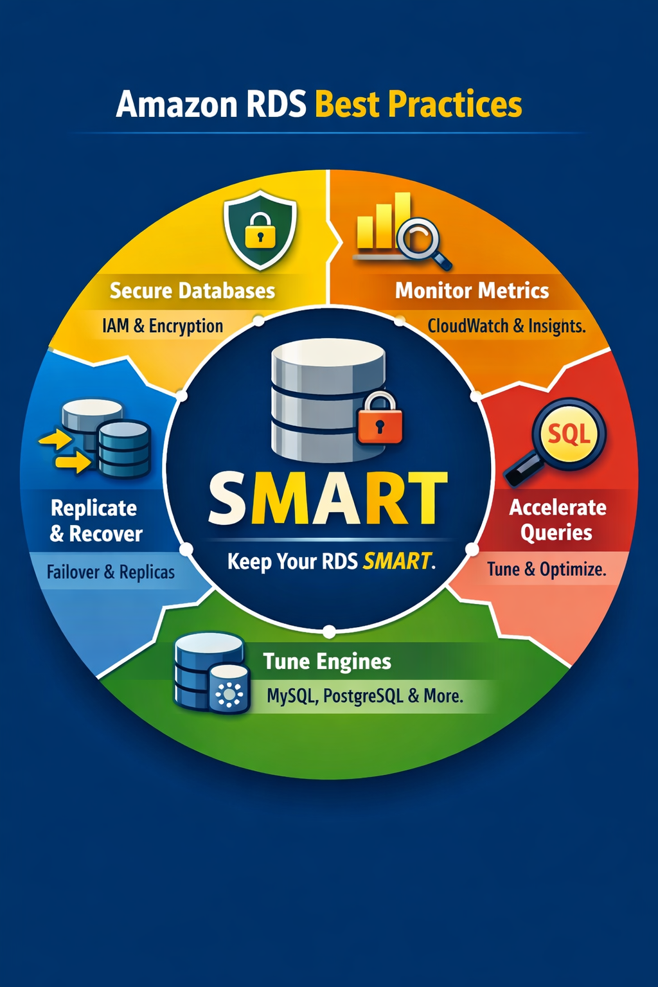
Here’s a clean, slide-ready summary of IAM best practices in bullet points:

🔐 Identity Management
- Avoid using the root user for daily tasks.
- Create IAM users, groups, and roles for operational access.
- Use IAM Identity Center for centralized workforce identity management.
🛡️ Least Privilege Principle
- Start with no permissions by default.
- Grant only necessary access for specific tasks.
- Refine broad permissions over time to minimize exposure.
🔑 MFA & Credential Hygiene
- Enable Multi-Factor Authentication (MFA) for all users.
- Set password complexity and rotation policies.
- Regularly rotate access keys used for programmatic access.
📜 Policy Management
- Use managed or custom policies to define access.
- Attach policies only to identities that require them.
- Avoid overly permissive policies like *:*.
📊 Monitoring & Auditing
- Review IAM policies for outdated or excessive permissions.
- Use IAM Access Analyzer to detect unintended access.
- Track activity with AWS CloudTrail for audit trails.
